Exercise 9

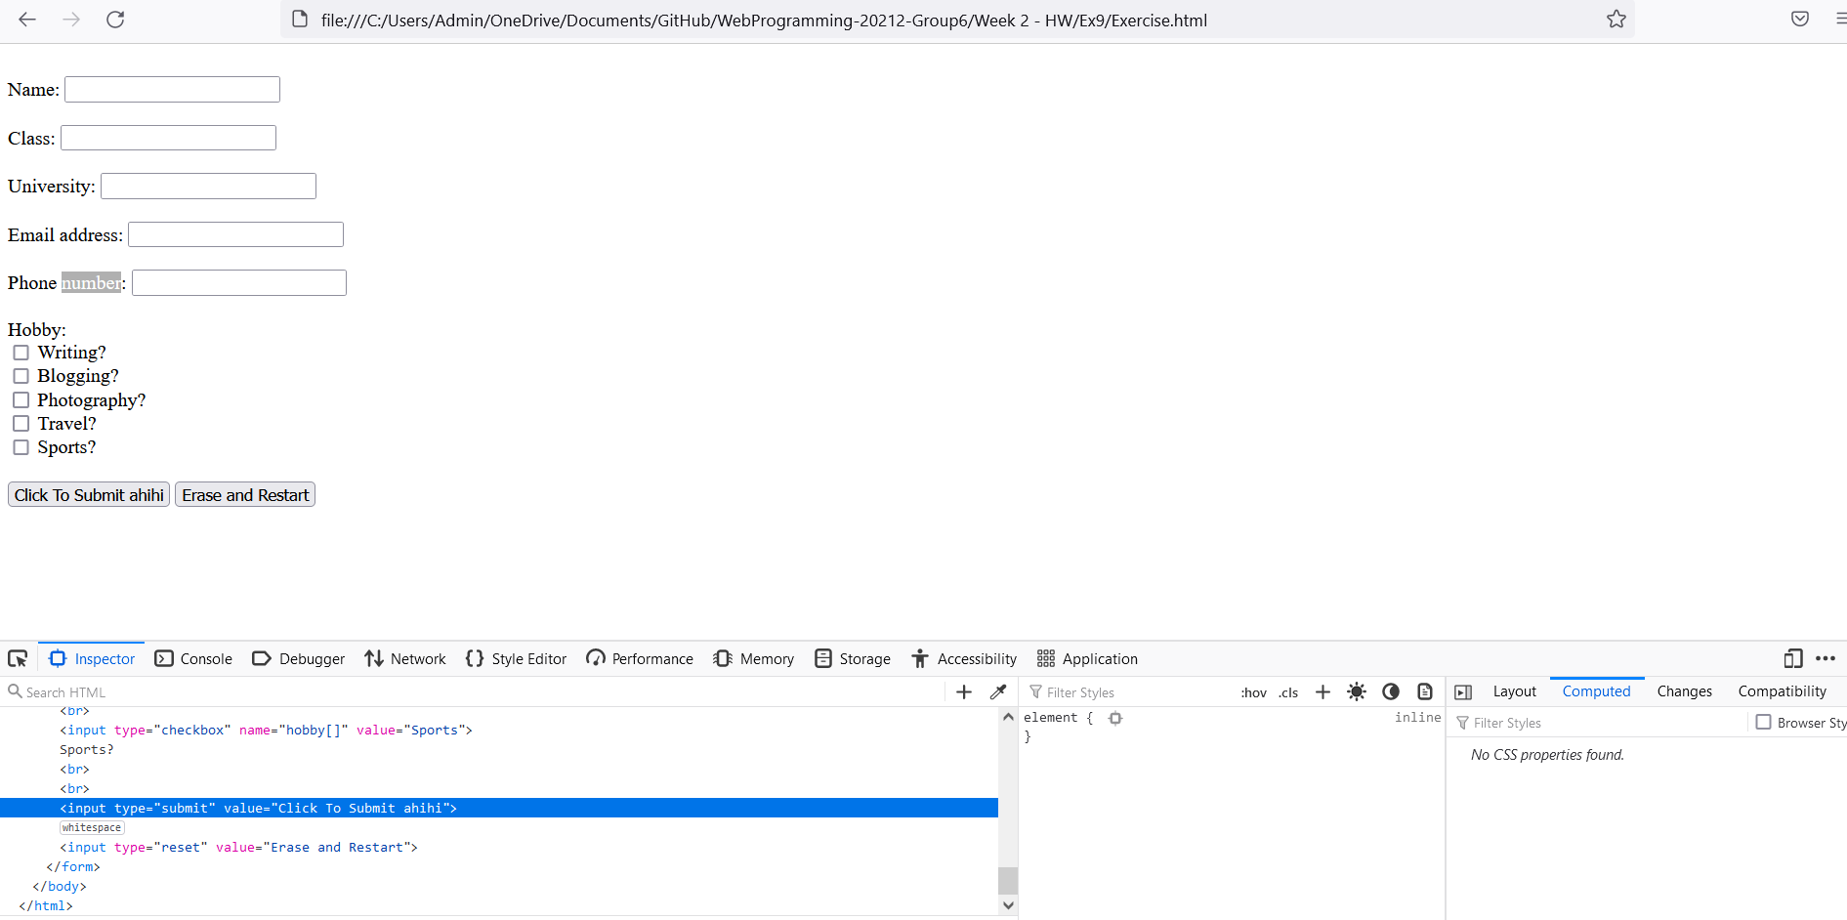

Figure : View html and css, change html and css